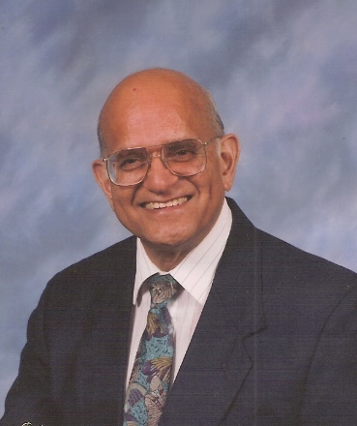
Obituary for Pastor Jack Sequeira
Born on September 25, 1932 in Nairobi, Kenya, to parents from Goa, India, Jack lived a long and fruitful life. He suffered a disabling stroke and fell asleep in Jesus on March 26, 2022 in a Portland, Oregon, hospital.
Jack served the Seventh-day Adventist Church in many capacities in England, Uganda, Kenya, Ethiopia, and the United States.
After graduating from Newbold College, England, he trained students in the colporteur work, for the South England Conference. After studying at Andrews University, he served in Uganda as Education, Missionary Volunteer, and Home Missionary Secretary in 1965. Then he was called to Kenya to teach at Kamagambo Teacher Training College near Kisii, and Maxwell Secondary School in Nairobi, (1966-68). He returned to Uganda as Education and Missionary Volunteer Secretary, (1969) and then as Principal of Bugema Adventist College (1971-72).
Being included in Idi Amin’s notorious Exodus, when 80,000 Asians were deported from Uganda, Jack and his family had to leave everything in their home and stayed in Beirut, Lebanon, the headquarters of the Afro Mideast Division. Later, Pastor Jack was assigned to Ethiopia, (1973-77), then back to Kenya as Chaplain for the SDA students in government universities (1978-82).
In 1982 the family moved to the US to fulfil General Conference requirements related to their refugee status due to their Uganda experience. Jack served as a District Pastor for the Idaho Conference until 1987, when he was called to pastor the Walla Walla City Church in the Upper Colombia Conference. From 1991-2001 he served the Potomac Conference as pastor of the Capital Memorial Church in Washington, DC.
Pastor Jack was known around the world for his infectious smile and biblical preaching from the Word of God; the book of Romans; and Righteousness by Faith. He firmly believed in salvation by faith accomplished by Christ over two thousand years ago and was used by the Lord to bring many to a better understanding of our Creator God.
He is survived by his wife, Jean, daughter Jenny, son, Chris and wife Nenette, and their children Jazmine, Parker, Shasta, and Luis.

